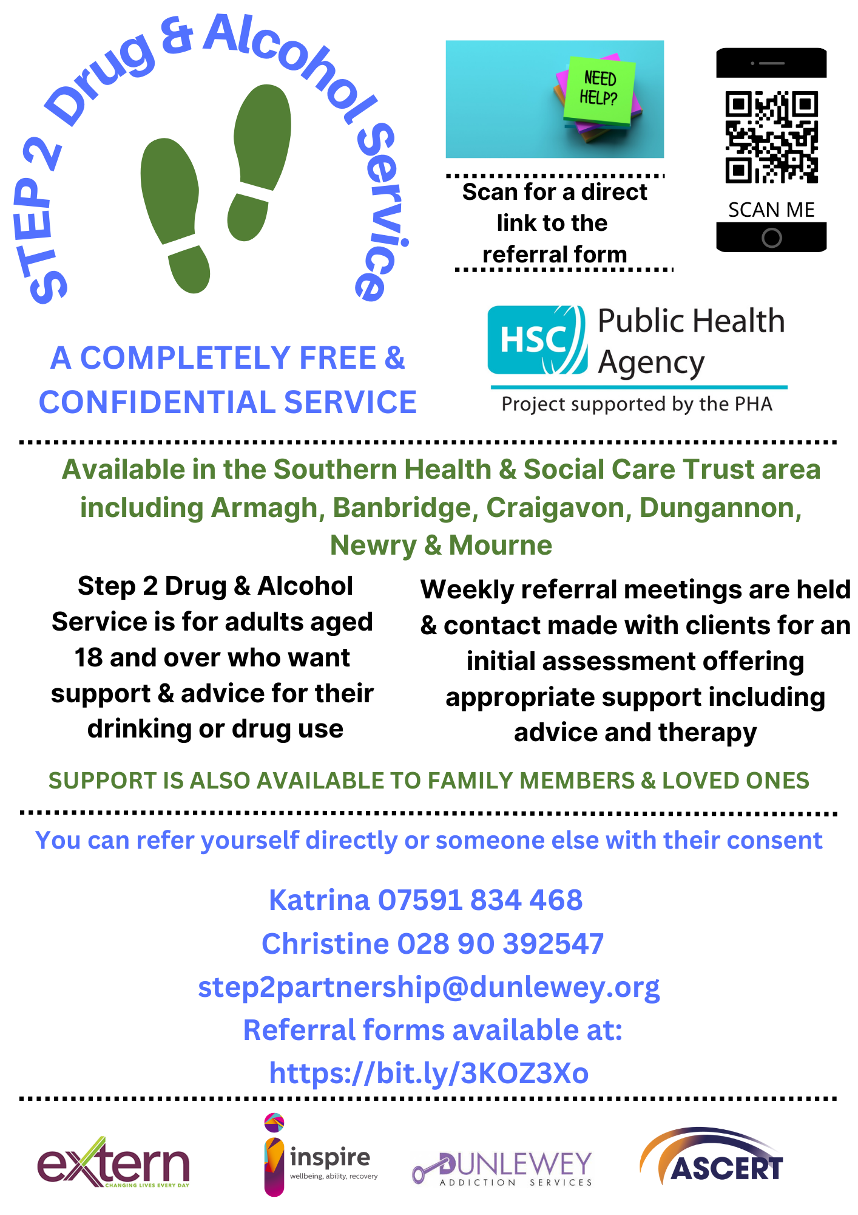

**DO YOU NEED HELP WITH YOUR DRUG OR ALCOHOL USE?**