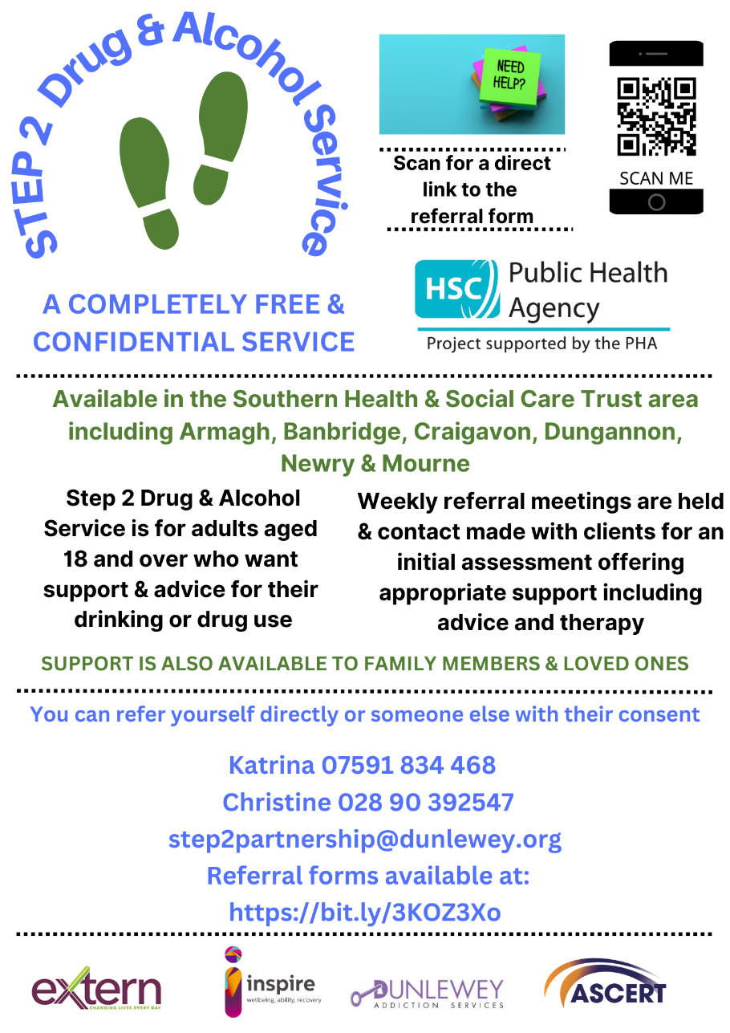

**SOUTHERN TRUST AREA**

**STEP 2 DRUG AND ALCOHOL SERVICE PARTNERSHIP**

**Step 2 Service** **Referral Form**

**Referral Details: (circle)**

Self Organisation Relative Friend CAT

Date of referral:___________________

Consent given by service user*: Yes / No

Nb. The details below will be shared with the Step2 Partnership, comprising Inspire Addiction Services, ASCERT, Dunlewey Addiction Service & Extern.

**MODE OF COUNSELLING PREFERRED, PLEASE HIGHLIGHT / CIRCLE BELOW**

FACE TO FACE / TELEPHONE / VIDEO CALL

**DETAILS OF PERSON BEING REFERRED**

|  |  |
| --- | --- |
| **Name** |  |
| **Date of Birth** |  |
| **Address** |  |
| **Postcode** |  |
| **Telephone Number** |  |
| **Email address** |  |

**Substance/s** (Circle) - Alcohol Cannabis Cocaine Heroin

Other/s________________________________________________________

Quantity/ How much _____________________ Daily Weekly Monthly (please circle)

**AUDIT Score:** LDQ: Alcohol LDQ: Drugs

Health issues Yes / No

Mental Health Yes / No

**GP & Practice Details:** (if known)

|  |  |
| --- | --- |
| **GP Practice** |  |
| **Address** |  |
| **Telephone Number** |  |

**Referred By:**

|  |  |
| --- | --- |
| **Name** |  |
| **Organisation (if applicable)** |  |
| **Address** |  |
| **Telephone** |  |
| **Email** |  |
| **How did you hear of Step2 Partnership?** |  |
| **Interpreter required?** | Yes / No |
| **Language** |  |

**Notes: for example - Risk factors**

Completed by: ____________________________________

**S2P ref No: Step2 Partnership**

