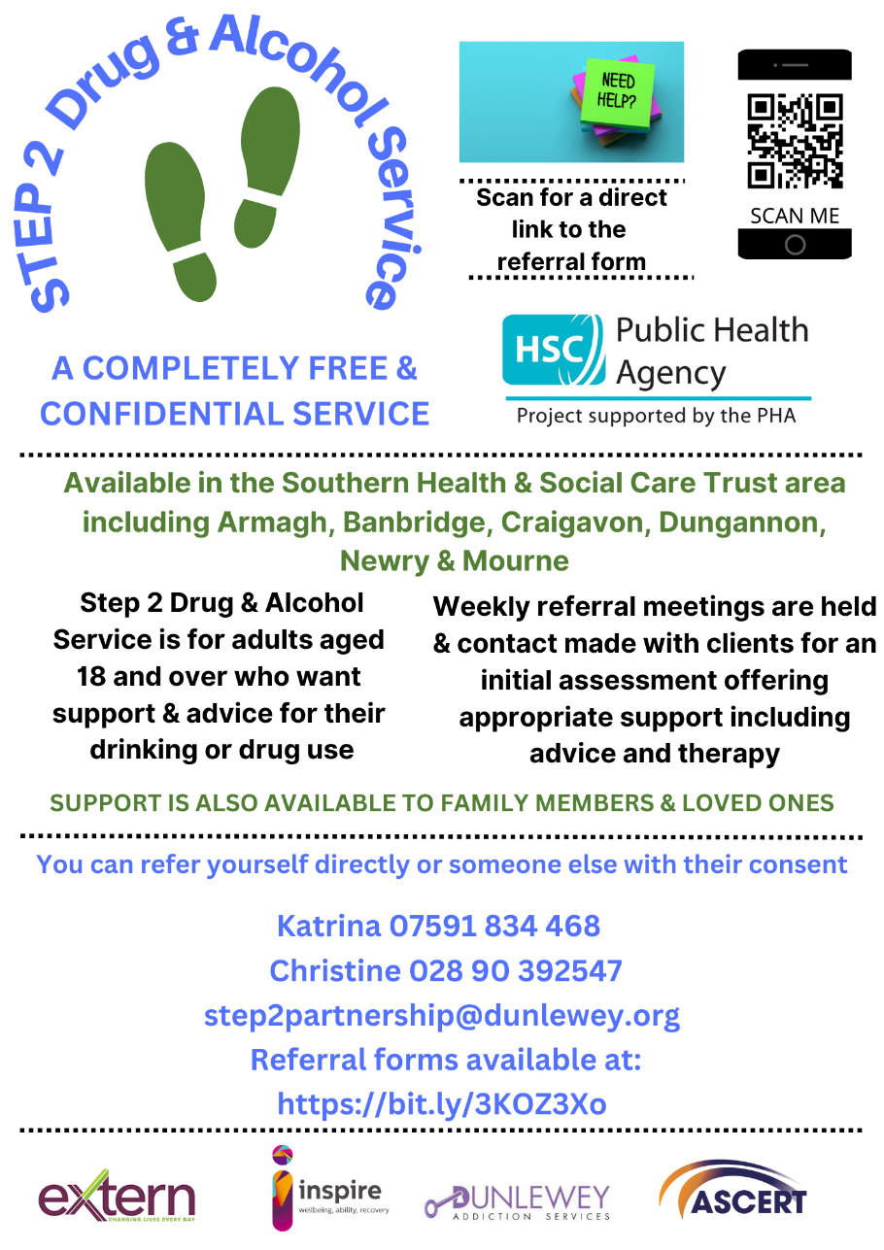

**Southern Trust Area**

**Step 2 Drug and Alcohol Service Partnership**

**Referral Form for Family Support**

‘Family Support’ is available for people affected by another person’s use of substance/s. whether or not the person using substance/s is having treatment. This form is for the referral of family members or other people affected by a person’s substance use.

For Step 2 treatment for the person using substances, please use our other referral form.

**REFERRAL SOURCE: (circle)**

|  |  |  |  |  |
| --- | --- | --- | --- | --- |
| Self | Organisation | Relative | Friend | Community Addictions Team (CAT) |

Date of referral: _______________________

**HAS CONSENT BEEN GIVEN BY SERVICE USER*:** Yes / No

Nb. The details below will be shared with the Step2 Partnership; comprising Inspire Addiction Services, ASCERT, Dunlewey Addiction Service, Extern and the SHSCT Community Addictions Team.

**MODE OF COUNSELLING PREFERRED, PLEASE HIGHLIGHT / CIRCLE BELOW**

FACE TO FACE / TELEPHONE / VIDEO CALL

**DETAILS OF PERSON BEING REFERRED:**

|  |  |
| --- | --- |
| **Name** |  |
| **Date of Birth** |  |
| **Address** |  |
| **Postcode** |  |
| **Telephone Number** |  |

**NOTES E.G. CIRCUMSTANCES, NEEDS, RISK FACTORS:**

**REFERRED BY:**

|  |  |
| --- | --- |
| **Name** |  |
| **Organisation (if applicable)** |  |
| **Contact Tel / Email:** |  |
| **How did you hear of Step2 Partnership?** |  |
| **Interpreter required?** |  |
| **Language** |  |

**(For office use)**

Completed by: ____________________________________

**S2P ref No:**  **Step2 Partnership**

**WHERE TO SEND YOUR REFERRAL FORM TO:**

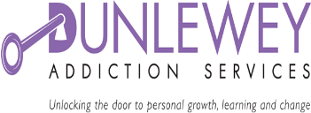**Please send your completed referral form to** [**Step2Partnership@dunlewey.org**](mailto:Step2Partnership@dunlewey.org) **or alternatively Telephone 028 9039 2547 or 07591 834 468. **

