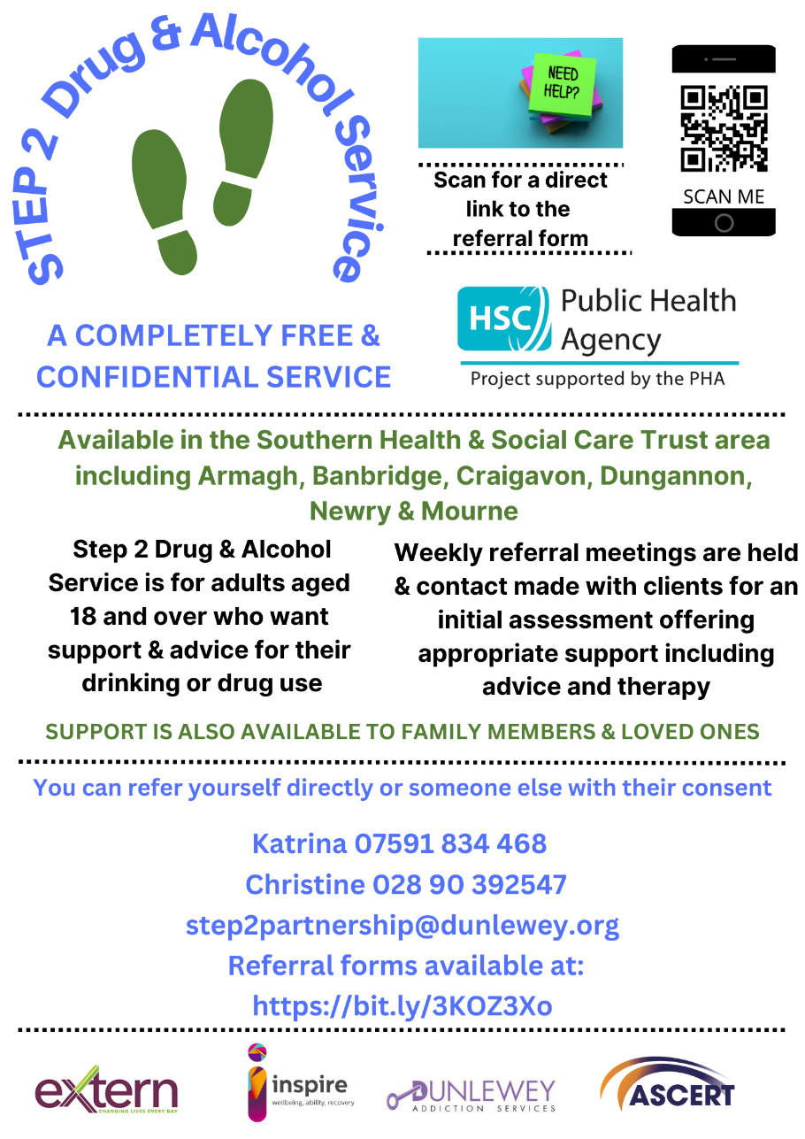

**Southern Trust Area**

**Step 2 Drug and Alcohol Service Partnership**

**Referral Form for Family Support**

‘Family Support’ is available for people affected by another person’s use of substance/s. whether or not the person using substance/s is having treatment. This form is for the referral of family members or other people affected by a person’s substance use.

For Step 2 treatment for the person using substances, please use our other referral form.

**Referral Source: (circle)**

Self Organisation Relative FriendCAT

Date of referral: _______________________

Consent given by person/s being referred for Family Support*: Yes / No

Nb. The details below will be shared with the Step2 Partnership, comprising Inspire Addiction Services, ASCERT, Dunlewey Addiction Service & Extern.

**MODE OF COUNSELLING PREFERRED, PLEASE HIGHLIGHT / CIRCLE BELOW**

FACE TO FACE / TELEPHONE / VIDEO CALL

**DETAILS OF PERSON BEING REFERRED**

|  |  |
| --- | --- |
| **Name** |  |
| **Date of Birth** |  |
| **Address** |  |
| **Postcode** |  |
| **Telephone Number** |  |

Notes e.g. circumstances, needs, risk factors:

**Referred By:**

|  |  |
| --- | --- |
| **Name** |  |
| **Organisation (if applicable)** |  |
| **Contact Tel / Email:** |  |
| **How did you hear of Step2 Partnership?** |  |
| **Interpreter required?** |  |
| **Language** |  |

**(For office use)**

Completed by: ____________________________________

**S2P ref No:**  **Step2 Partnership**

**Please send your referral form to** [**Step2Partnership@dunlewey.org**](mailto:Step2Partnership@dunlewey.org)

**Or alternatively telephone: Katrina 07591 834 468 / Christine 028 9039 2547**